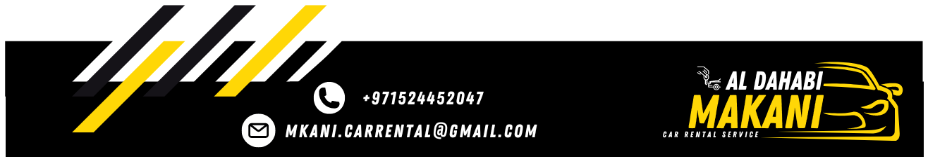

Local Purchase Order
To: GOLDEN KEY RENT CAR L.L.C | LPO NO: 1502260101
To: GOLDEN KEY RENT CAR L.L.C | Date: 10/02/2026

Greetings,
Further to our conversation, I would like to confirm the below mentioned car.

Type of Care | CHEVROLET CORVETTE
Model | 2024
Plate No. | 50193
Plate Code | CC
Color | Orange/Black
Rate | 800 per day

The lease period 2 days, or more days you have to list that MKANI responsible for damage, fines and Salik, We thank you for your cooperation with us.
Best Regards,

MKANI ALDHAHABI CAR RENTAL L.L.C Manager: MOHAMED REDA

