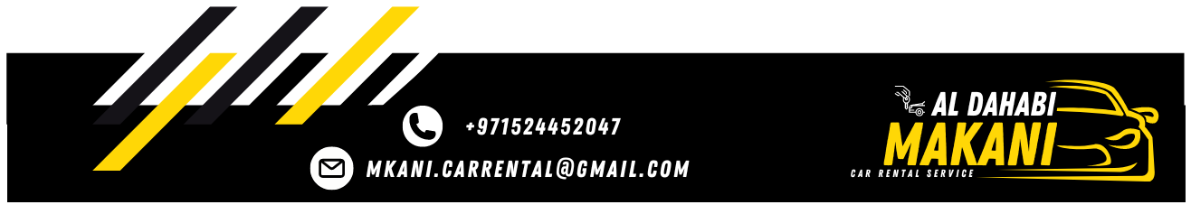

Local Purchase Order
To: ELITE WHEELS CAR RENTAL L.L.C S.O.C | LPO NO: 0902261929
To: ELITE WHEELS CAR RENTAL L.L.C S.O.C | Date: 09/02/2026

Greetings,
Further to our conversation, I would like to confirm the below mentioned car.

Type of Care | JETOUR T2
Model | 2025
Plate No. | 79482
Plate Code | X
Color | Black
Rate | 6000

The lease period 30 days, or more days you have to list that MKANI responsible for damage, fines and Salik, We thank you for your cooperation with us.
Best Regards,

MKANI ALDHAHABI CAR RENTAL L.L.C Manager: MOHAMED REDA

