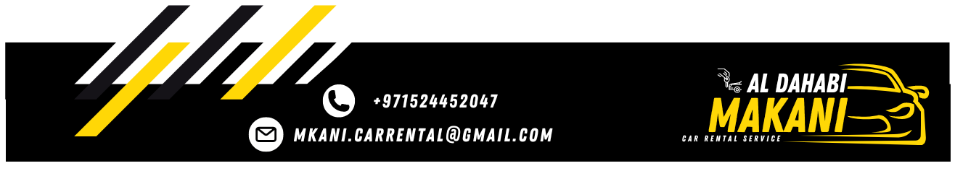

Local Purchase Order
To: GOLDEN KEY RENT CAR L.L.C | LPO NO: 0802262124
To: GOLDEN KEY RENT CAR L.L.C | Date: 26/02/2024

Greetings,
Further to our conversation, I would like to confirm the below mentioned car.

Type of Care | CHEVROLET CORVETTE
Model | 2024
Plate No. | 50193
Plate Code | CC
Color | Orange/Black
Rate | 500

The lease period 26 days, or more days you have to list that MKANI responsible for damage, fines and Salik, We thank you for your cooperation with us.
Best Regards,

MKANI ALDHAHABI CAR RENTAL L.L.C Manager: MOHAMED REDA

