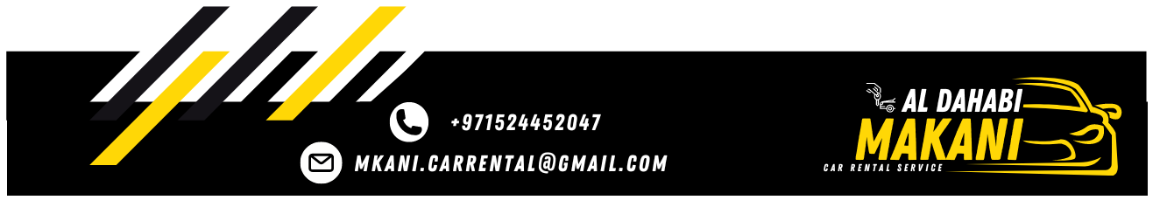

Local Purchase Order
To: Qusai | LPO NO: 52637
To: Qusai | Date: 07/02/2026

Greetings,
Further to our conversation, I would like to confirm the below mentioned car.

Type of Care | RANGE ROVER SPORT
Model | 2017
Plate No. | 47713
Plate Code | FF
Color | White Black
Rate | 550 AED / Daily

The lease period 15 days, or more days you have to list that MKANI responsible for damage, fines and Salik, We thank you for your cooperation with us.
Best Regards,
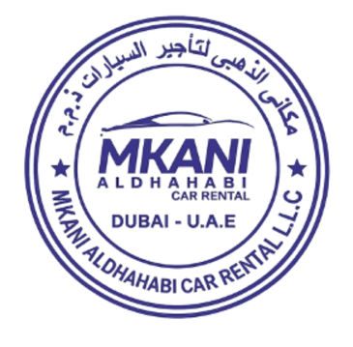
MKANI ALDHAHABI CAR RENTAL L.L.C Manager: MOHAMED REDA

