

عقد أيجار RENTAL AGREEMENT
NO:
Hirer Details
اﺳﻢ Name: | Qusai Haider Khair Zahed
ﺟﻨﺴﻴﺔ Nationality: | Syrian Arab Republic
ﺟﻮاز ﺳﻔﺮ / رﻗﻢ ﺑﻄﺎﻗﺔ اﻟﻬﻮﻳﺔ  Passport / I.D. No.: | 784-1997-3797597-1
ﺗﺎرﻳﺦ اﻻﻧﺘﻬﺎء Date: Expiry | 20/11/2026
ﺗﺎرﻳﺦ اﻟﻮﻻدة Birth: of Date | 05/01/1997
رﻗﻢ اﻻﺗﺼﺎل No: Contact | 0505088969

Driver Details
اﺳﻢ Name: | Qusai Haider Khair Zahed
ﺟﻨﺴﻴﺔ Nationality: | Syrian Arab Republic
رﻗﻢ رﺧﺼﺔ اﻟﻘﻴﺎدة No: Lic. Driving | 4993923
ﻣﻜﺎن ﺻﺪوره Issue: of Place | Dubai
ﺗﺎرﻳﺦ اﻟﻤﺴﺄﻟﺔ Issue: of Date | 01/08/2025
ﺗﺎرﻳﺦ اﻻﻧﺘﻬﺎء Expiry: of Date | 01/08/2027

R8 2025
Black
DXB F 14253
Audi
Vehicle Details
Vehicle Type:
Plate No: Color:
Model:
E
F

OUT | Date: | KM Out: | IN | Date: | KM In:
OUT | Time: | Given By: | IN | Time: | Rec By:

Terms & Conditions | Charge Details
I acknowledge that I have read and agreed to the conditions on both sides of this agreement as below:  - The lease holder shall bear AED ………, in case of an accident in addition to the rental charges or during the repair period.  - Dubai Salik charges will be collected from the day of pickup; they will be added to the rental amount in the contract and collected by using the hirer's physical card or cash immediately, or using their card number in case of future payments.  - The lease holder has to pay the full amount of the car value if it is conﬁscated by government authorities.  - The lease holder received the car in good condition, except the damages noted while collecting the car.  - The lease holder has agreed to all the conditions mentioned above and undersigned.  I acknowledge that I have read this agreement and the terms and conditions mentioned behind this contract and received the car in good condition, except for the damages shown in the diagram. I also conﬁrm that it is necessary to deduct from me any amounts, ﬁnes, violations, current service fees, or deduct any other amounts without informing me. My signature below acknowledges that the amount will be debited from my credit card, to the total amount owed, now or in the future, and I signed it.er  The owner of the credit card shown below is authorized for car rental to deduct all dues from rents, fines, damage insurance, road fees, taxes, etc. without reference to him.  Card Number  EXPIRY DATE:………………………………………………………………………………………………………………………………………..  SIGNATURE :……………………………………………………………………………………………………………………………………….. | Base Rental
  CREDDIT CARD DETAILS
 | No of Days
 | Traﬃc Fines
 | Tolls
 | Other Charges
 | Deposit
 | Discount
 | TAX
 | Grand Total
 | Balance
 | 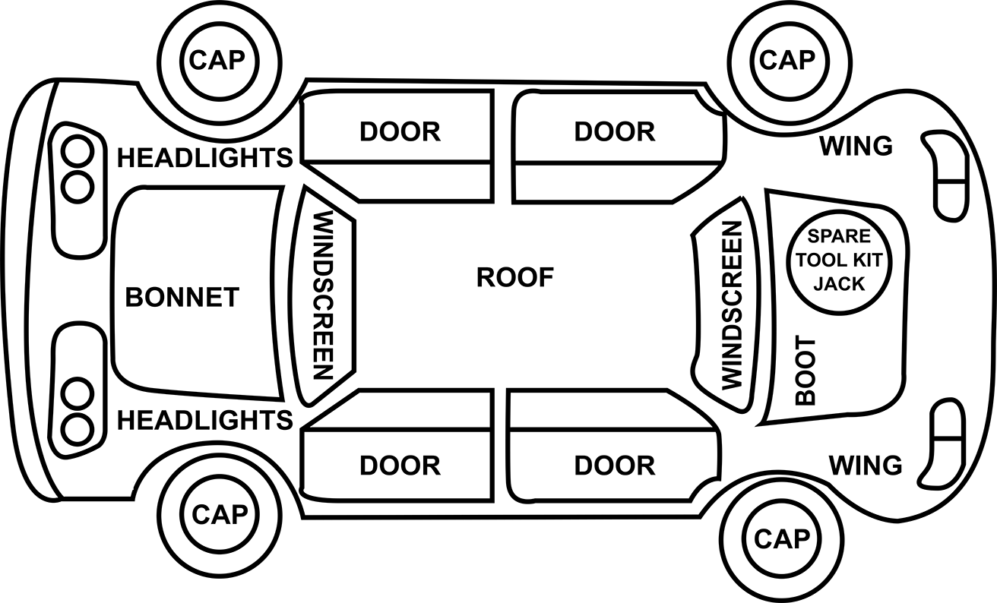

.............................. .............................. ..............................
Sign of Hirer Sign of Driver Sign of Employee

